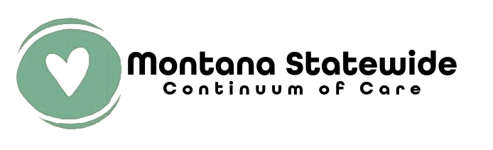

FY2026 CoC NOFO Local Project Application

All new projects wishing to apply for Montana Statewide Continuum of Care (CoC) funding in the FY2026 HUD CoC Competition must complete the following information and submit it in PDF format via email to submit@mtcoc.org by 5pm (MDT) on July 28, 2026.
If your project is selected for inclusion in the Montana Statewide Continuum of Care 2026 Project Priority Listing, you will need to submit a project application in e-snaps. Applicants will be notified of their status by 5pm (MDT) on Wednesday, August 5, 2026. Selected projects will need to submit a new Project Application by 5pm (MDT), Monday, August 10, 2026.

Applicant Information
Name of Agency
Name of Project
UEI (if applicable)
SAM # (if applicable)
Primary Contact Name
Primary Contact Email
Secondary Contact Name
Secondary Contact email

Project Information
- The project component is:
  - ☐ Transitional Housing
  - ☐ Support Services Only

- Proposed Start Date:

- Amount of funding requested: $

Experience of Applicant, Subrecipient(s), and Other Partners (2 points)
- Describe your organization’s (and subrecipient(s) if applicable) experience in effectively utilizing Federal funds and performing the activities proposed in the application:
- Describe your organization’s (and subrecipient(s) if applicable) experience in leveraging Federal, State, local and private sector funds:
- Describe your organization’s (and subrecipient(s) if applicable) financial management structure:

Project Description: Program and Service Expectations (3 Points)
- Provide a description of the project. This MUST include the following: Entire scope, who the project will serve, activities offered and staffing:
- Indicate the maximum number of units and beds available for project participants:
  - Units:
  - Beds:
Supportive Services for Participants: Scope and Outcomes (3 points)
Supportive Service  Indicate Which Services will be Provided | Provider  Applicant or Partner | Frequency  Daily, Weekly, or  As Needed, etc.
Assessment of Service Needs
Assistance with Moving Costs
Case Management
Child Care
Education Services
Employment Assistance and Job Training
Food
Housing Search and Counseling Services
Legal Services
Life Skills Training
Mental Health Services
Outpatient Health Services
Outreach Services
Substance Abuse Treatment and Recovery Services
Transportation
Utility Deposits

- Provide a description of the project’s scope of services and expected outcomes:

Budget (1 point)
Eligible Costs | Costs Requested (1yr Term)
Leasing
Supportive Services
Operating
HMIS
VAWA
Rural
Subtotal of CoC Program Costs Requested
Admin Costs (up to 10 of Subtotal)
HUD funded Subtotal + Admin Costs
Match (Cash or In-Kind), Must be 25% Subtotal + Admin costs
Total Project Budget for This Grant Including Match

Subreciepient Organization | Funding Allocation

Implementation Timeline (1point)
- Number of Days until hiring staff or expending funds begins:
- Number of Days until program participant enrollment begins:
- Number of Days until leased units and/or supportive services are near 100% capacity:

Signature
By signing this form, you are agreeing that you are an authorized representative of the organization listed below and that you have verified and attest to the content of this application as submitted.
Authorized Representative Name:
Title:
Date:

